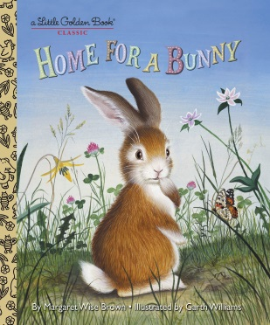
Interactive Read Aloud
Home for A Bunny
By Margaret Wise Brown

Warm Up-This book is about a brown bunny who tries to find a home; you can see the brown bunny pictured on the cover of the book. Oh, no! Look at the brown bunny’s face in the illustration on the cover of the book; how do you think he feels about trying to find a home? Show me with your face how you think he feels. Do you think the brown bunny will ever find a home? If you think the brown bunny will find a home, nod your head for yes. If you think the brown bunny won’t find a home, shake your head for no. Let’s read the words to find out more information about this brown bunny and his search for a home.
Connection-All the animals in the book so far are yelling about spring being here. But how do they know it’s spring? Can you point out any evidence on these two pages that it is spring? How about here? How do you know it’s spring here at our school? Let’s look out the windows of our classroom so you can point out evidence of spring here at our school.
Think Aloud-It looks like the brown bunny is having some trouble finding a home. Here on these pages, he checked with the robins and the nest didn’t work for him. Here on these pages, he checked with the frog and the water didn’t work for him. But why not? Why doesn’t the brown bunny want to live in a nest? Hmmm…maybe he might fall out of it. Can you add to my thinking? What are some other reasons? Why doesn’t the brown bunny want to live in the water? Hmmm…maybe he will get too wet. Can you add to my thinking? What are some other reasons why?
Prediction-What do you think the white bunny will say? Where will the white bunny say his home is?
Think, Pair, Share-Why do you think the white bunny invited the brown bunny to join him in his home? Think of a reason why. Tell yourself the reason. Now, pair up and share why you think the white bunny chose to share his home with the brown bunny.
Wrap Up-Hooray! The brown bunny did find a home! How do you think he feels about finding a home? Show me with your face how you think he feels about finally finding a home. What clues from this page in the book did you use to find out how the brown bunny feels?

